Strategic Plan
2020-2023

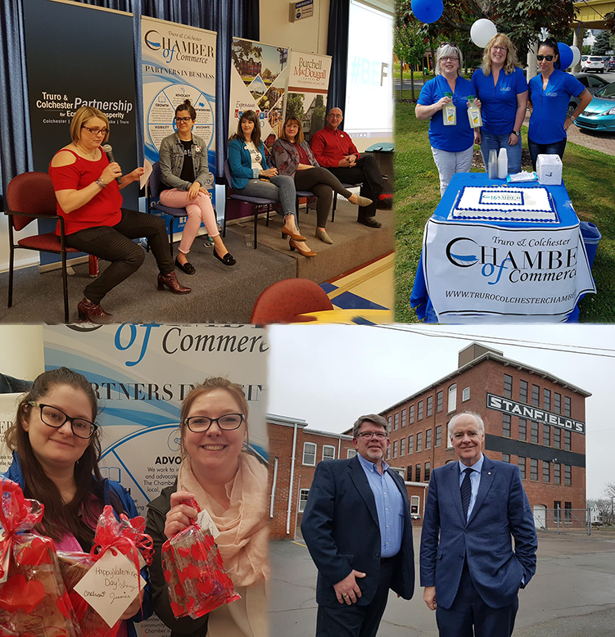
June 8, 2020
Amanda Mombourquette, MCS Consulting

contents
Vision 1
Mission 1
Values & Commitment 1
Partners In Business 2
Strategic Directions 3
Value in Membership 3
Creating Conditions for Economic Growth 4
Stakeholder Engagement 4
Communications & Marketing 5
Organizational Excellence 6
Priority Areas 7
Contact 7

Vision
The Colchester business community is collaborative, connected, and thriving.

Mission
To be the voice of, and act in the best interest of business in Truro & Colchester on matters of economic, social and political impact; we are committed to business growth in our communities.

Values & Commitment
We will advance our vision and mission according to a series of fundamental principles of professional practice for our organization. We are:
- Professional Connectors – We drive connections between people, businesses, governments and communities to create the maximum benefit for the economy of Truro and Colchester County.
- Leaders in Advocacy – In influencing policy/regulation, we take a consistent approach to being champions for positive change to address the challenges and opportunities our members are facing every day.
- Responsive & Timely – We consistently act in the best interests of our collective membership, providing services that meet their business growth needs when they need it.
- Accountable to Members – Our responsibility is to our members first, all others second. In our strategic planning, operations, and financial management, our members will be engaged and informed.
- Authoritative Voice for All of Colchester County – We are the only county-wide business organization that is membership driven, so our actions will reflect the authority and integrity of our broad membership base.
- Impactful and Inclusive – We are dedicated to growing our membership through strategies such as delivering return on investment, ensuring broad sectoral and cultural representation at the board level and in our membership, and providing responsive advocacy and programs to ensure that we are a leader in creating conditions for growth.

Partners In Business
The Truro & Colchester Chamber of Commerce enjoys a reputation for embodying these core values within our community, across the province, and at regional and national levels. Our retention rate of 94% among members is the result of a forward-thinking and effective team that has developed a reputation of delivering results.

Our networking opportunities and educational programs have become highly anticipated, our advocacy work has reached national levels, and our money-saving programs for businesses have increased dramatically. Membership numbers, event attendance, sponsor relationships, and participation in our Member to Member program have all strengthened significantly in the last three years. The increasing level of engagement with business and government is built on a foundation of organizational excellence to ensure we remain effective and efficient in the face of rapidly changing economic conditions.

We determine the priorities of businesses and the impact of Chamber initiatives through annual surveys to our membership to ensure we are on track and providing an opportunity for every member to contribute to the Chamber’s priorities. We’re not just here to support our members, we’re here to be a partner in business.

Strategic Directions
Over the next three years, we will focus our efforts on creating conditions for growth for all businesses in Colchester County. Our priority will be to grow our membership inclusively, reflecting all sectors of our economy and communities. We are mandated to promote and protect the interests of the business community and we will do so by focusing on five strategic directions.

Value in Membership
To ensure that our members see a return on their investment in the Chamber, and to drive membership growth, our team will continue to deliver the highest quality programming and services possible. We are committed to continuously improving our value proposition to members by customizing our offerings to the challenges and opportunities being faced by the business community. Our ability to deliver value will be further supported by creating a welcoming environment where entrepreneurs, whether they are long-standing or new residents in the area, can leverage the power of membership by providing opportunities to advance and strengthen business.
- Review and build core membership benefits
  - Expand Chambers Plan reach and build awareness of new offerings such as Teladoc
  - Expand Member-to-Member discount plan to incent local shopping/supply chains
- Advocate for and inform members on matters of importance to their business
  - Partner with other organizations to leverage advocacy efforts
  - Share “wins” of all sizes with members to ensure they are aware of the work of the Chamber on their behalf
- Customize networking and educational events to address the most pressing needs/desires of businesses including political events, employee attraction/retention, succession planning, cash flow management, taxation, etc.
- Celebrate business success and convene business groups to learn from each other

Creating Conditions for Economic Growth
Turning 130 years old in 2020, we have a long and rich history of advocating for positive policy changes to ensure that Colchester County businesses enjoy an increasingly better business climate. The Chamber is in a unique position to represent the interests of its members, and we will be proactive as the collective voice for business on the toughest issues. Our goal is to be a leader in the development of practices and policy to support progressive business conditions in Colchester County.
- Advocate for better conditions for business on issues impacted by government policy including health care, taxation, regulation, exporting, economic development, broadband and cellular coverage, public transit, tourism/festival supports, etc.
  - Contribute to physician recruitment efforts to ensure that at least a minimum standard of care for citizens in Colchester County is maintained
  - Survey/connect with members regularly on “hot topics” for their business
  - Look for synergies with other groups in a collaborative approach to advocacy
  - Seek opportunities to improve government relations across a variety of departments/agencies to be better prepared to both influence responsible policy-making and respond to unexpected policy or economic changes
- Support businesses in attracting and retaining employees
  - Contact businesses to discuss their HR needs
  - Offer education workshops that respond to the needs of businesses and/or contribute to the productivity of employees
- Provide leadership and financial support to the Truro and Colchester Partnership for Economic Prosperity (Regional Enterprise Network)
- Support the administration of the Visitor Information Centre

Stakeholder Engagement
As we work to advance economic development initiatives in the region, we will continue to focus on developing strategic alliances with partners such as NSCC, Dalhousie University, and municipalities to build the strongest collaborative network possible. The efforts of the Chamber culminated in December 2017 with the creation of the Regional Enterprise Network (Truro and Colchester Partnership for Economic Prosperity). While continuing to support this critical effort, our renewed focus will be on identifying new partners, collaborating with organizations that represent specific sectors, and government relations.
- Actively welcome new members to the business community (member attraction)
- Reach out to agricultural, IT, educational, and other sectoral associations to build new relationships and opportunities to partner on initiatives
- Connect with government departments to identify opportunities for improvement in policy
- Develop a personal approach to connecting with new members

Internally, we will continue to provide our Board of Directors and volunteers with tools and programs that will ensure their valuable time results in tangible results for the organization and business community in general. Our goal is to leverage the strengths of all stakeholders to create a stronger Chamber, and a stronger business community in Colchester County.

Communications & Marketing
At the heart of every Chamber of Commerce is an informed and engaged membership; we are only as strong as our ability to connect and communicate with, about, and for businesses in the region. That’s why our strategic plan includes communications and marketing as a key strategic direction. What does a chamber do for its members? Why join the chamber? What is the Chamber’s impact on the economy? Who is the Chamber? These are common questions asked by new and existing businesses in our region; not only do we need to be ready with a clear and concise answer, we also need to be proactively pushing out the answers to these questions and more to ensure our voice is recognized and heard. It’s a crowded field in the economic development world in Nova Scotia, so it comes down to a single key concept – differentiation.
- Develop a marketing mix that reaches across platforms and media to achieve continuous awareness building
  - Assign budgetary resources and develop content to mitigate cost
  - Develop media and other partnerships
- Establish key messages outlining our value proposition/ROI/vibrancy
  - Identify legacy statistics (over a 5-year span) that speak to the value of the Chamber (i.e. 94% retention)
- Highlight the stories of members and partners to illustrate the impactful work of the Chamber
  - Enhance our visual presence by creating videos showcasing members
- Leverage the expertise of Board and Committee members to create compelling stories about business success and the need for an independent organization like the Chamber
  - Connect to what we do (and what we don’t do)
- Ensure the Chamber’s physical presence in the community is visible and clear

Organizational Excellence
We will act with integrity and accountability in the delivery of Chamber programs and services. Board governance and succession planning, strong financial accountability, the pursuit of efficiencies internally and with other boards, along with regular reporting to our membership will be key in ensuring that our programs are delivered from a strong organizational foundation. Our goal is to ensure the longevity of the Chamber as an advocacy organization, operating at the highest of standards, that improves the business climate of Colchester County.
- Document and practice strong financial and operational management procedures
  - Develop an annual budget that plans for strategic investments in areas that will improve business conditions and/or strengthen the organization
  - Prioritize the generation of non-dues revenue
- Seek opportunities to conduct staff professional development and conduct regular staff appraisals
- Adopt best practices for board and committee governance
  - Develop a board skills matrix to identify talent attraction targets for incoming board members and outline opportunities for the professional growth of board members through their involvement in the Chamber
  - Provide Board orientation packages to all existing and new board members that includes by-laws, financial statements, committee information, policy statements, etc.
  - Ensure that regular Board meetings and committee meetings are held in order to advance the priorities of the Chamber
  - Ensure that committees have defined terms of reference and seek opportunities to leverage the strengths of committee members to extend the reach and impact of Chamber initiatives
- Achieve re-accreditation through the Chamber Accreditation Council of Canada (CACC) to demonstrate the highest level of standards and practices (rigorous national standards of policy, service and performance)

Priority Areas
Recognizing the importance of strategically managing limited assets, priorities have been established in order to maintain focus and increase the effectiveness of the Chamber’s efforts in the region. From the Strategic Directions identified, particular effort will be extended to:
- Advocate for better conditions for business on issues impacted by government policy including health care and physician recruitment
- Customize networking and educational events to address the most pressing needs/desires of businesses including political events, employee attraction/retention, succession planning, cash flow management, taxation, etc.
- Leverage the strengths of committee members to extend the reach and impact of Chamber initiatives
- Establish key messages outlining our value proposition/ROI/vibrancy

On the first point regarding advocacy, there has never been a more important time for businesses to work together and to have a strong advocate as this year has been. 2020 has been a year of pandemic resulting in “The Great Shutdown” of the Canadian economy, compounded by tragedy in our communities. The Atlantic Canadian GDP dropped more this year so far than it ever has since being recorded; that reality is reflected in the impacts to businesses in our region.

Our Chamber mobilized early, providing a central resource page, using social media to more effectively communicate when businesses were making adjustments to protect health and safety, providing updates to members on relevant programs and announcements, educating businesses on the impacts to expect and how to get help, and advocating for specific support from government to not only get us through this crisis, but to stimulate economic growth once the immediate danger has passed.

As we plan for the next 3-5 years, we keep these unprecedented and extreme experiences front-of-mind to ensure we remain sustainable, adaptable, and of service to our members. The definition of a Chamber of Commerce is “a local organization of businesses whose goal is to further the interests of businesses” – that remains our commitment to our members and to the economy of Truro and Colchester County.

Contact
605 Prince Street  Truro, Nova Scotia  B2N 1G2 |  | ed@tcchamber.ca  902-895-6328  https://www.trurocolchesterchamber.com

